Patient Intake system

The system is designed for an outpatient clinic. The intent of the application is to schedule appointments, collect patient information, send appointment notifications to the patients.

Project structure

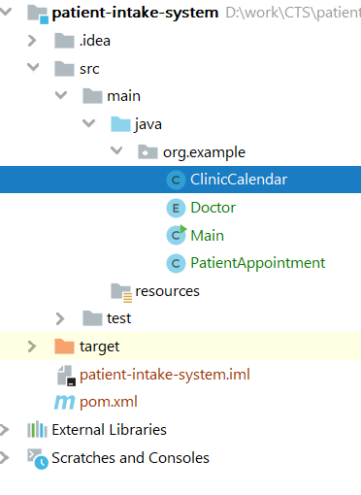**Main** class

This is the startup class; this uses console input and output to communicate with the user, this has a main menu with 2 subsystems

1. Add a patient appointment
2. View all appointments

**ClinicCalendar** class

Represents the schedule of the clinic. All the appointments are stored in a list. This has the following functions. Add an appointment

1. View all appointment

**PatientAppointment** class

Represents a patient of the clinic.

**Doctor** enum

Represents a doctor in the system

Requirements

1. Use Lombok to add getters and setters in PatientAppointment class.
2. Use Lombok to add an all-argument constructor in PatientAppointment class.
3. Date format to be used is *dd-M-yyyy hh:mm a*
4. All the exceptions must be logged in a separate file named *error.log*
5. All the successful appointments must be logged into a separate file named *activity.log*
6. Sample log format*: Mon 13:03:12 09/11/2020 [restartedMain] [INFO] [TomcatWebServer] - Tomcat started on port(s): 8080 (http) with context path ''*
7. Perform code quality analysis using sonarqube
8. Perform code coverage analysis using jacoco

Test Cases

* ClinicCalendar class, create a new appointment and add it into the calendar.
* Verify that the appointment is added, and the appointment date is in the correct format.
* Verify that an exception is thrown when invalid date time format is submitted.